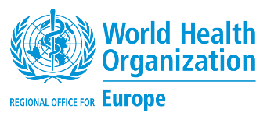

Launching of the First Perinatal Mortality Audit Report

in North Macedonia 2019

Thursday 19 November 2020, 13:00 – 14:00

Programme
13:00 – 13:20 | Opening session  Dr Venko Filipche, Minister of Health  Dr Jihane Tawilah, WHO Representative  Dr Nino Berzuli, Director, Division of Country Health Programmes, WHO Regional Office for Europe  Ms Patrizia Di Giovanni, UNICEF Representative
13:20 – 13:40 | Findings from of the first perinatal mortality audit in North Macedonia for the year 2019  Dr Gligor Tofoski, President of the National Perinatal mortality audit committee  Ms Natalie Roos, Karolinska Institute, WHO Consultant  Dr Khatuna Lomouri, WHO Consultant
13:40 – 13:55 | Feedback from the audience  Session moderated by Ms Margarita Spasenovska, WHO North Macedonia
13:55 – 14:00 | Closing remarks  Dr Elizabeta Georgievska, First Lady  Dr Jihane Tawilah, WHO Representative

Simultaneous translation in both Macedonian and English languages will be available.

